**Family Tree User Manual**

**Overview**

The FamilyTree program can be used to easily maintain and retrieve family tree information. Information saved includes: Name, Nick Name, SEX, Birthdate, Canonical Birth Date, Birth Order, Death Date, Canonical Death Date, Birth Place, Death Place, external documentation file(s), external document description, Date Added, Date Updated, etc. With one click it can link from an individual’s record to the record for spouse, a parent, brothers and sisters and children.

It can also be used to generate HTML files that serve the same purpose and function in a similar manner.

**Installation**

Copy the entire folder "Family Tree" (along with its contents) from the installation from the distribution media onto your hard drive.

You may need to install the 32-bit AccessDatabaseEngine:

<https://download.microsoft.com/download/2/4/3/24375141-E08D-4803-AB0E-10F2E3A07AAA/AccessDatabaseEngine.exe>

The Database Engine is used to connect to the MS Access database *FamilyTree.MDB* which is used by the program to store family tree information.

In the *Utilities* menu, *Family Tree Options* menu item, dialog specify the locations for data to be used by the program.

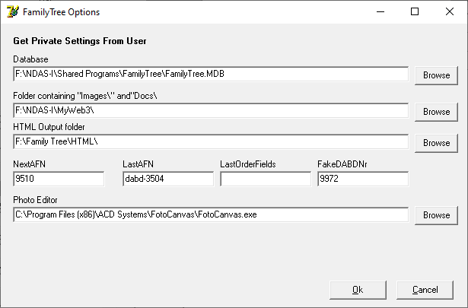

The *Database* field specifies where the MS Access database can be found.

The “*Folder containing “Images\ and Docs\”* specifies a parent folder which will contain both the “*Images\”* and “*Docs\”* sub-folders.

The *images* folder will contain all the JPEGs used to be displayed by the program.

The docs folder will contain any external documentation referenced by the program.

The “*HTML Output folder”* is where the generated HTML (optional) will be stored.

The *Photo Editor* can contain the path to a photo editor which can be used to edit the photos.

**Using the program**

Compile the program to FamilyTree.exe. Inside of the "Family Tree" folder on your hard disk, double click on the file "FamilyTree.exe". This should start the program. It is possible that your anti-virus program might complain. If so, you may have to mark this program as "safe" to your anti-virus program.

The program should open to view the last person who was previously viewed.

**Contents of the "Family Tree" folder**

|  |  |
| --- | --- |
| **Documentation** | Folder containing this User Manual |
| **FamilyTree.exe** | The Family Tree program |
| **FamilyTree.ini** | "ini" file which remembers the last viewed record and other information about where files are located. |
| **FamilyTree.mdb** | MicroSoft Access database containing the individual records |
| **HTML** | Folder containing records as individual html files (there are about 10,000 files in this folder) |
| **Images** | Folder Containing the photos accessed by the database |

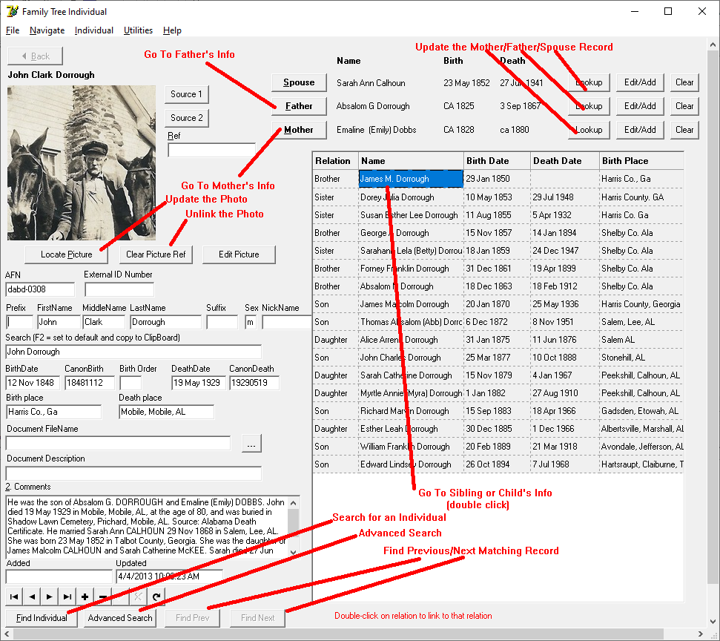

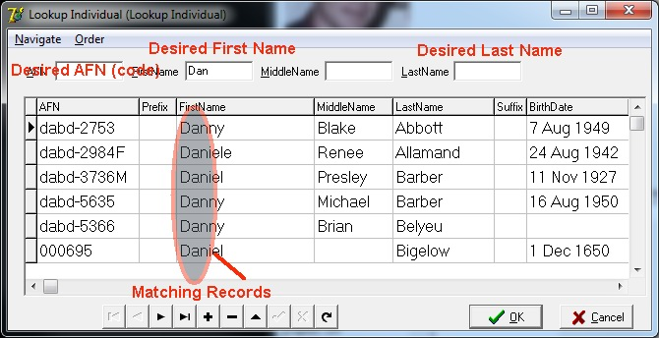

**Lookup Individual**

To search for an individual’s record, simply start typing into the First Name, Middle Name, Last Name or AFN field at the top. Matching records will be shown immediately, narrowing down as more characters are typed. To select an individual, click OK or double-click on the desired name.

**Advanced Search**

To do an "Advanced Search" fill in any known information and then press "Ok". All matching records will be displayed. Select the desired record.

